**CLASS ASSIGNMENT 1**

**Basic Table Creation, Data Insertion, and Simple Queries**

**Create Database:**

*create database SHOP;*

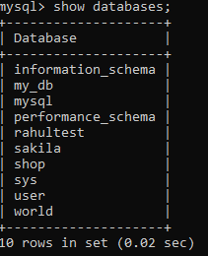**Output:**

**Create Tables:**

1. **CLIENT_MASTER:**

*create table client_master (*

*client_no VARCHAR(6) NOT NULL,*

*name VARCHAR(20) NOT NULL,*

*address1 VARCHAR(30),*

*address2 VARCHAR(30),*

*city VARCHAR(15),*

*pincode INTEGER(8),*

*state VARCHAR(15),*

*bal_due DECIMAL(10,2),*

*PRIMARY KEY(client_no)*

*);*

**OUTPUT:**

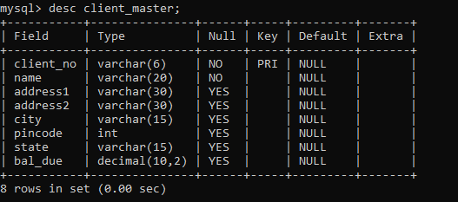

1. **PRODUCT_MASTER:**

*create table product_master(*

*product_no VARCHAR(6) NOT NULL,*

*description VARCHAR(15) NOT NULL,*

*profit_percentage DECIMAL(4,2) NOT NULL,*

*unit_measure VARCHAR(10) NOT NULL,*

*qty_on_hand INT(8) NOT NULL,*

*reorder_lvl INT(8) NOT NULL,*

*sell_price DECIMAL(8,2) NOT NULL,*

*cost_price DECIMAL(8,2) NOT NULL,*

*PRIMARY KEY(product_no)*

*);*

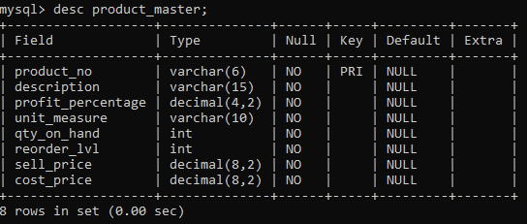 **OUTPUT:**

1. **SALESMAN_MASTER:**

*create table salesman_master(*

*salesman_no VARCHAR(6) NOT NULL,*

*salesman_name VARCHAR(20) NOT NULL,*

*address1 VARCHAR(30) NOT NULL,*

*address2 VARCHAR(30),*

*city VARCHAR(20),*

*pincode INT(8),*

*state VARCHAR(20),*

*sal_amt DECIMAL(8,2) NOT NULL,*

*tgt_to_get DECIMAL(6,2) NOT NULL,*

*ytd_sales DECIMAL(6,2) NOT NULL,*

*remarks VARCHAR(60),*

*PRIMARY KEY(salesman_no)*

*);*

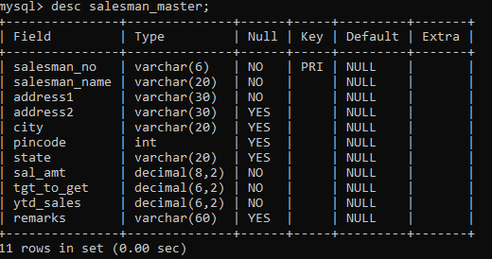**OUTPUT:**

1. **SALES_ORDER:**

*create table sales_order(*

*order_no VARCHAR(6) NOT NULL,*

*client_no VARCHAR(20) NOT NULL,*

*order_date DATE NOT NULL,*

*dely_addr VARCHAR(30),*

*salesman_no VARCHAR(6) NOT NULL,*

*dely_type CHAR(1) DEFAULT 'F',*

*bill_yn CHAR(1),*

*dely_date DATE,*

*order_status VARCHAR(10),*

*PRIMARY KEY(order_no),*

*FOREIGN KEY(client_no) REFERENCES client_master(client_no),*

*FOREIGN KEY(salesman_no) REFERENCES salesman_master(salesman_no)*

*);*

**OUTPUT:**

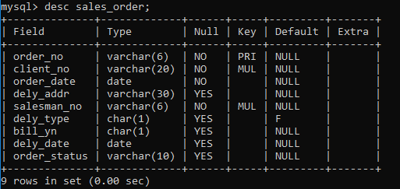

1. **SALES_ORDER_DETAILS:**

*create table sales_order_details(*

*order_no VARCHAR(6),*

*product_no VARCHAR(6),*

*qty_ordered INT(8),*

*qty_disp INT(8),*

*product_rate DECIMAL(10,2),*

*FOREIGN KEY(order_no) REFERENCES sales_order(order_no),*

*FOREIGN KEY(product_no) REFERENCES product_master(product_no)*

*);*

**OUTPUT:**

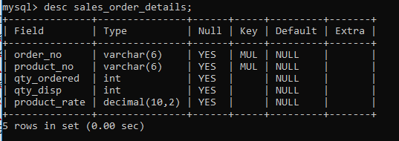

**Insert Data Into Table:**

1. **Insert into client_master:**

*INSERT INTO client_master (client_no, name, address1, address2, city, pincode, state, bal_due) VALUES*

*('C00001','Ivan Bayross','F -111',NULL,'Bombay','400054','Maharashtra',15000),*

*('C00002','Vandana','F-112',NULL,'Madras','780001','Tamil Nadu',0),*

*('C00003','Praveen','F-113',NULL,'Bombay','400057','Maharashtra',5000),*

*('C00004','Basu','F-114',NULL,'Bangalore','560001','Karnataka',0),*

*('C00005','Ravi','F-115',NULL,'Delhi','110005','Delhi',2000),*

*('C00006','Rukhmani','F-116',NULL,'Bombay','400060','Maharashtra',0);*

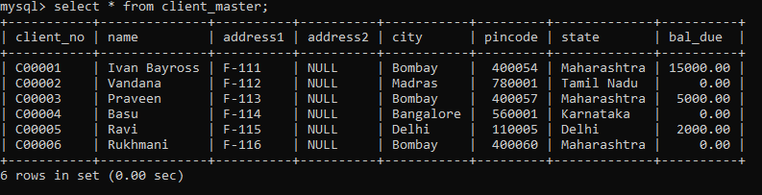**OUTPUT:**

1. **Insert into product_master:**

*INSERT INTO product_master (product_no, description, profit_percentage, unit_measure, qty_on_hand, reorder_lvl, sell_price, cost_price) VALUES*

*('P00001','1.44 Floppies',5,'Price',100,20,525,500),*

*('P00002','Monitors',6,'Price',10,3,12000,11280),*

*('P00003','Mouse',5,'Price',20,5,1050,1000),*

*('P00004','1.22 Floppies',5,'Price',100,20,525,500),*

*('P00005','Keyboard',2,'Price',10,3,3150,3050),*

*('P00006','540 HDD',2.5,'Price',10,3,5250,5100);*

**OUTPUT:**

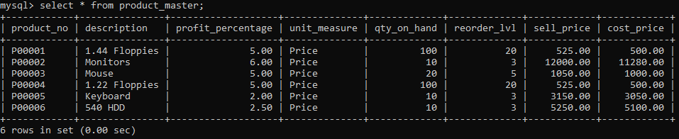

1. **Insert into salesman_master:**

*INSERT INTO salesman_master (salesman_no, salesman_name, address1, address2, city, pincode, state, sal_amt, tgt_to_get, ytd_sales, remarks) VALUES*

*('S00001','Aman','A/14','Worli','Mumbai',400002,'Maharashtra',3000,100,50,'Good')*

*('S00002','Omkar','65','Nariman','Mumbai',400001,'Maharashtra',3000,200,100,'Good'),*

*('S00003','Raj','P-7','Bandra','Mumbai',400032,'Maharashtra',3000,200,100,'Good'),*

*('S00004','Ashish','A/5','Juhu','Mumbai',400044,'Maharashtra',3500,200,150,'Good');*

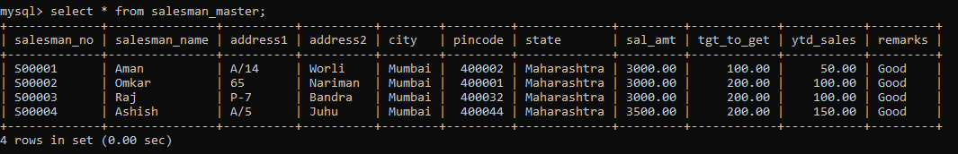**OUTPUT:**

1. **Insert into sales_order:**

*INSERT INTO shop. sales_order (order_no , client_no, order_date, dely_addr, salesman_no, bill_yn, dely_date, order_status) VALUES*

*('O19001','C00001',STR_TO_DATE('12-JUN-02', '%d-%b-%y' ) , NULL, 'S00001', 'N', STR_TO_DATE('20-JUL-02','%d-%b-%y'), 'In Process') ,*

*('O19003','C00003',STR_TO_DATE('18-FEB-02', '%d-%b-%y') , NULL, 'S00003', 'Y', STR_TO_DATE('20-FEB-02','%d-%b-%y'), 'Fulfilled') ,*

*('O19004','C00004',STR_TO_DATE('03-APR-02', '%d-%b-%y'), NULL, 'S00001', 'Y', STR_TO_DATE('07-APR-02','%d-%b-%y'), 'Fulfilled') ,*

*('O19006','C00006',STR_TO_DATE('24-MAY-02', '%d-%b-%y'), NULL, 'S00004', 'N', STR_TO_DATE('26-JUL-02','%d-%b-%y'), 'In Process') ;*

*INSERT INTO shop. sales_order (order_no, client_no, order_date, dely_addr, salesman_no, dely_type, bill_yn, dely_date, order_status) VALUES*

*('O19002','C00002',STR_TO_DATE('02-JUN-02', '%d-%b-%y'), NULL, 'S00002', 'P', 'N', STR_TO_DATE('27-JUN-02','%d-%b-%y'), 'Cancelled') ,*

*('O19005','C00005',STR_TO_DATE('20-MAY-02', '%d-%b-%y'), NULL, 'S00002', 'P', 'N', STR_TO_DATE('22-MAY-02','%d-%b-%y'), 'Cancelled');*

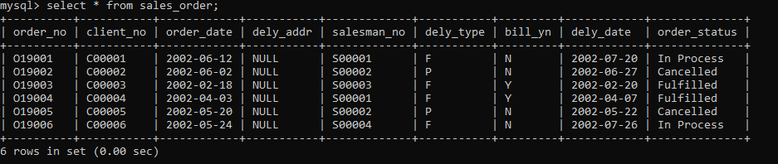**OUTPUT:**

1. **Insert into sales_order_details:**

*INSERT INTO shop.sales_order_details (order_no, product_no, qty_ordered, qty_disp, product_rate) VALUES*

*('O19001','P00001',4,4,525),*

*('O19001','P00006',2,1,5250),*

*('O19002','P00001',10,0,525),*

*('O19003','P00005',3,3,3150),*

*('O19003','P00006',3,1,5250),*

*('O19003','P00001',10,10,525),*

*('O19003','P00002',4,4,1050),*

*('O19004','P00002',2,2,1050),*

*('O19004','P00003',1,1,12000),*

*('O19006','P00001',10,5,525);*

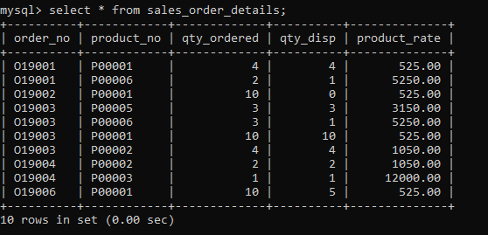**OUTPUT:**

**Query Processing:**

1. **List the product number, description, and the corresponding selling price for the products, with the selling price lying between Rs. 500 and Rs. 750.**

*SELECT product_no, description, sell_price FROM product_master WHERE sell_price BETWEEN 500 AND 750;*

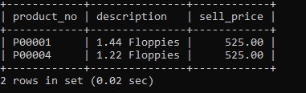**OUTPUT:**

1. **Display the order numbers and order dates for all the orders placed in the months of May and June.**

*SELECT order_no, order_date FROM sales_order WHERE DATE_FORMAT(order_date, '%M') IN ('May', 'June');*

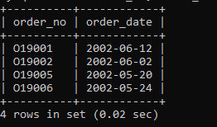**OUTPUT:**

1. **List the product number, description, and aggregate quantities for the orders placed by ‘Ravi’ and ‘Basu.’**

*SELECT pm.product_no, pm.description, sub.total_qty_ordered AS total_qty_ordered*

*FROM shop.product_master pm*

*JOIN (*

*SELECT sod.product_no, SUM(sod.qty_ordered) AS total_qty_ordered*

*FROM shop.sales_order_details sod*

*WHERE sod.order_no IN (*

*SELECT so.order_no FROM shop.sales_order so*

*WHERE so.client_no IN (*

*SELECT cm.client_no FROM shop.client_master cm*

*WHERE cm.name IN ('RAVI', 'BASU')))*

*GROUP BY sod.product_no )*

*AS sub ON pm.product_no = sub.product_no;*

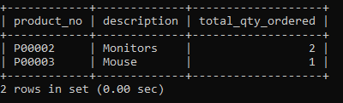**OUTPUT:**